NAME: Shriya Ramya Mohan ROLL:NO: 241901106

EXPERIMENT - 4
SQL INJECTION LAB

AIM:

To perform SQL Injection Lab in TryHackMe platform to exploit vulnerabilities.

ALGORITHM:
1.Access the SQL Injection Lab in TryHackMe platform.
2.Click Start AttackBox to run instance of kali linuc distribution.
3.Perform SQL injection attacks on following-
a)Input Box Non-String
b)Input Box String
c)URL Injection
d)POST Injection
e)UPDATE Statement.
4.Perform broken authentication of login forms with blind SQL injection to extract admin password.
5.Perfrom UNION-based SQL injection and exploit the funtion and retrieve the flag.

OUTPUT:

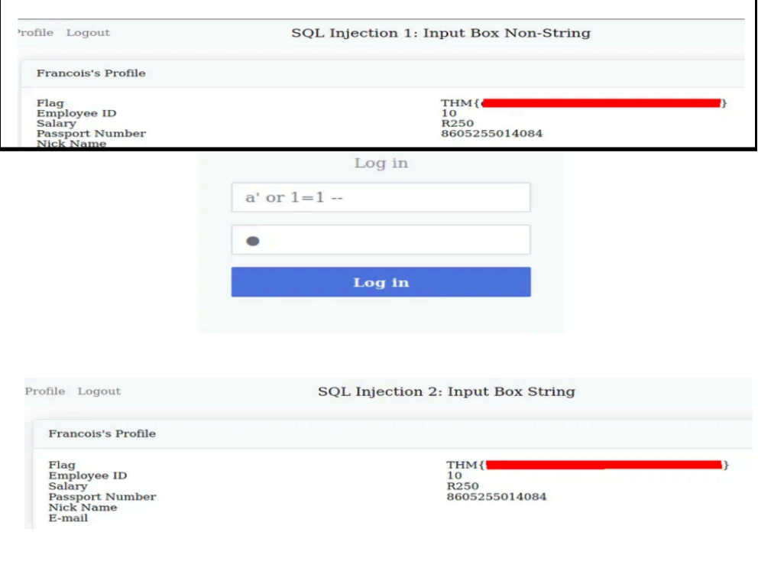

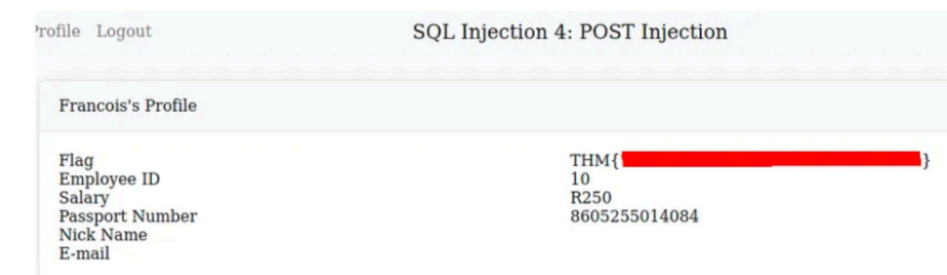

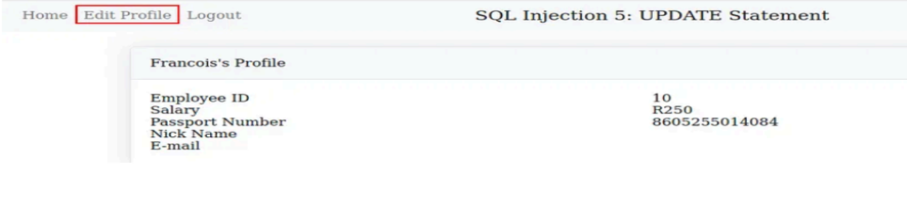

RESULT:

Thus,the variety exploits were performed using SQL Injection Attack.

